CONFIDENTIAL  CS/NOV 2026/ICT450

UNIVERSITI TEKNOLOGI MARA
MARKING SCHEME

COURSE :
COURSE CODE :
EXAMINATION :
TIME :
DATABASE DESIGN AND DEVELOPMENT
ICT450
NOVEMBER 2026 (MOCK)
3 HOURS

MARKING SCHEME NOTES

- This marking scheme accompanies the ICT450 mock paper (November 2026).
Answers are unofficial model answers, not official UTM marking schemes.

- Marking points state the expected answer and the allocation of marks; every question retains its source paper and page reference.

- Five questions x 20 marks; total = 100 marks.
- Real-bank questions: 5. Placeholders: 0.
Questions and answers are for local study use only.

- Structure derived from 12 unique ICT450 past papers; every real question remains traceable to its source page.

FOR MARKERS' USE ONLY

This marking scheme consists of 6 printed pages.
MARKING GUIDE
QUESTION 1 (20 marks)
Source: ICT450-2019-JUN · page [2, 3] · bank id ICT450-2019-JUN-Q1
Reference answer
(a) Traditional file system and database redesign. [8 marks]
• i) Problems: data is duplicated across separate files; programs depend on file layouts; sharing and security are weak; the same update must be repeated in several files.
• ii) Database approach: integrate the separate files into one logical database managed by a DBMS, define a shared schema and keys, and let applications access data through the DBMS rather than through private files.
(b) Mobile database characteristics and SRC applications. [8 marks]
• Characteristics: location independence and ubiquitous access; synchronization with a central database; limited device resources.
• Application 1: a campus event and announcement app for students — SRC can push updates and students can read them anywhere.
• Application 2: a shuttle or campus facility status app — students see live locations and schedules.
• Reason: students carry mobile devices and need timely, location-aware information.
(c) Primary keys in the course schema. [4 marks]
• i) COURSE: CourseCode; SUBJECT: SubjectCode; TEACHER: TeacherCode; COURSE_SUBJECT: (CourseCode, SubjectCode).
• ii) A primary key uniquely identifies each row, prevents duplicate records and enforces entity integrity.
Marking guide
• a)(i) 4 marks for two file-system problems.
• a)(ii) 4 marks for a database redesign with shared schema/DBMS.
• b) 2 marks for each characteristic and 2 marks for each application/reason (8).
• c)(i) 2 marks for all primary keys; (ii) 2 marks for the purpose.
Provenance: model_unofficial · confidence high · Model-authored from the approved question text, the supplied source assets and the ICT200/ICT450 knowledge base; no official ICT450 marking scheme was supplied.
Knowledge base basis: TOPIC 1 DATABASE CONCEPT (1).pdf; TOPIC 2 DATA MODEL (1).pdf; TOPIC 3 RELATIONAL DATA MODELstu.pdf

QUESTION 2 (20 marks)
Source: ICT450-2022-FEB · page [3, 4] · bank id ICT450-2022-FEB-Q2
Reference answer
(a) Conceptual, logical and physical design. [8 marks]
• Conceptual design — an abstract, software-independent model of entities, attributes and relationships derived from business rules.
• Logical design — maps the conceptual model to the chosen data model (usually relational tables, keys and constraints); it is software-dependent.
• Physical design — selects storage structures, indexes, file organisation and access paths; it is hardware- and software-dependent.
(b) Four big-data characteristics with examples. [8 marks]
• Volume — very large amounts of data; example: billions of daily e-commerce clicks.
• Velocity — data arrives and must be processed quickly; example: real-time payment fraud alerts.
• Variety — many formats; example: text, images, video and sensor data in one platform.
• Veracity — uncertainty in data quality; example: noisy social-media posts that need cleaning.
• Value is also accepted as an extended characteristic.
(c) Two spreadsheet features different from a database. [4 marks]
• A spreadsheet has no enforced relationships, primary keys or referential integrity; a database enforces them.
• A spreadsheet has limited multi-user concurrency, security and recovery; a database provides transaction control and central access rights.
Marking guide
• a) 2 marks for each design stage and 2 marks for the software-dependence point (8).
• b) 2 marks for each of four characteristics with example (8).
• c) 2 marks for each difference (4).
Provenance: model_unofficial · confidence high · Model-authored from the approved question text, the supplied source assets and the ICT200/ICT450 knowledge base; no official ICT450 marking scheme was supplied.
Knowledge base basis: TOPIC 2 DATA MODEL (1).pdf; TOPIC 6 DATABASE DESIGN (1).pdf

QUESTION 3 (20 marks)
Source: ICT450-2023-JUL · page [3, 4] · bank id ICT450-2023-JUL-Q3
Reference answer
The reservation form stores a reservation header, a repeating list of menu items and one selected facility.
(a) Define normalization and its purpose. [3 marks]
• Normalization is the staged process of removing repeating groups, partial dependencies and transitive dependencies from relations.
• Its purpose is to reduce redundancy and prevent insertion, update and deletion anomalies.
(b) Three effects of poor database design. [6 marks]
• Data redundancy — the same customer or menu data is stored many times.
• Update anomalies — a change must be repeated in several rows and can become inconsistent.
• Insertion/deletion anomalies — a new menu cannot be added without a reservation, or deleting a reservation removes the only menu record.
(c) Normalise to 3NF. [11 marks]
1NF: one row per reservation-menu line; key (ReservationID, MenuCode).
Flattened relation.
RESERVATION (ReservationID, ReservationDate, CustomerID, CustomerName, MenuCode, MenuName, MenuDescription, Quantity, FacilityCode, FacilityName, FacilityDescription)
2NF: remove customer, menu and facility partial dependencies.
2NF/3NF relations.
CUSTOMER (CustomerID, CustomerName)
FACILITY (FacilityCode, FacilityName, FacilityDescription)
MENU (MenuCode, MenuName, MenuDescription)
RESERVATION (ReservationID, ReservationDate, CustomerID, FacilityCode)
RESERVATION_MENU (ReservationID, MenuCode, Quantity)
3NF: the remaining non-key attributes depend on their table keys; no transitive dependency remains.
Marking guide
• a) 3 marks: definition and purpose.
• b) 6 marks: 2 marks for each effect.
• c) 11 marks: 1NF (2), 2NF (4), 3NF (5).
Provenance: model_unofficial · confidence medium · Model-authored from the approved question text, the supplied source assets and the ICT200/ICT450 knowledge base; no official ICT450 marking scheme was supplied.
Knowledge base basis: TOPIC 5 NORMALIZATION (1).pdf
Assumptions / notes
• The reservation form asset is a blank template; the answer models one reservation with many menu lines and one optional facility.

QUESTION 4 (20 marks)
Source: ICT450-2023-FEB · page [5] · bank id ICT450-2023-FEB-Q4
Reference answer
Ninja Package schema.
RIDER (riderID, riderName, startDate, hpNum)
CUSTOMER (icNum, custName, custPhone, custAddress)
DELIVERY (packageID, dateDeliver, riderID, icNum, status)
(a) Create the DELIVERY table. [4 marks]
CREATE TABLE DELIVERY (
packageID VARCHAR(10) NOT NULL,
dateDeliver DATE,
riderID VARCHAR(10) NOT NULL,
icNum VARCHAR(20) NOT NULL,
status VARCHAR(15) NOT NULL
CHECK (status IN ('delivered', 'unsuccessful')),
PRIMARY KEY (packageID),
FOREIGN KEY (riderID) REFERENCES RIDER (riderID),
FOREIGN KEY (icNum) REFERENCES CUSTOMER (icNum)
);
(b) Customers successfully receiving packages in November 2022. [4 marks]
SELECT COUNT(DISTINCT icNum) AS "
"successful_customers
FROM DELIVERY
WHERE status = 'delivered'
AND dateDeliver BETWEEN DATE '2022-11-01' AND DATE '2022-11-30';
(c) Unsuccessful deliveries per rider. [4 marks]
SELECT riderID, COUNT(*) AS unsuccessful_deliveries
FROM DELIVERY
WHERE status = 'unsuccessful'
GROUP BY riderID;
(d) Rider names that made at least one delivery. [4 marks]
SELECT DISTINCT r.riderName
FROM RIDER r
JOIN DELIVERY d ON d.riderID = r.riderID;
(e) Produce Package ID, Customer Name and Status. [4 marks]
SELECT d.packageID, c.custName, d.status
FROM DELIVERY d
JOIN CUSTOMER c ON c.icNum = d.icNum
WHERE d.status = 'delivered';
Marking guide
• a) 4 marks: columns (1), primary key (1), both foreign keys (1), status check (1).
• b) 4 marks: delivered filter (1), date range (1), COUNT DISTINCT (2).
• c) 4 marks: unsuccessful filter (2), GROUP BY rider (2).
• d) 4 marks: rider-delivery join and DISTINCT names.
• e) 4 marks: join (2), selected columns (1), status filter (1).
Provenance: model_unofficial · confidence high · Model-authored from the approved question text, the supplied source assets and the ICT200/ICT450 knowledge base; no official ICT450 marking scheme was supplied.
Knowledge base basis: TOPIC 7 SQL.pdf
Assumptions / notes
• Status is limited to 'delivered' or 'unsuccessful' by a check constraint.

QUESTION 5 (20 marks)
Source: ICT450-2024-JAN · page [6] · bank id ICT450-2024-JAN-Q5
Reference answer
The ERD models officers, duties, summonses, students and offenses. OFFICER_DUTY records duty dates, and SUMMON_OFFENSE resolves the many-to-many summons-offense relationship.
(a) Construct the ERD with Crow's Foot notation. [16 marks]
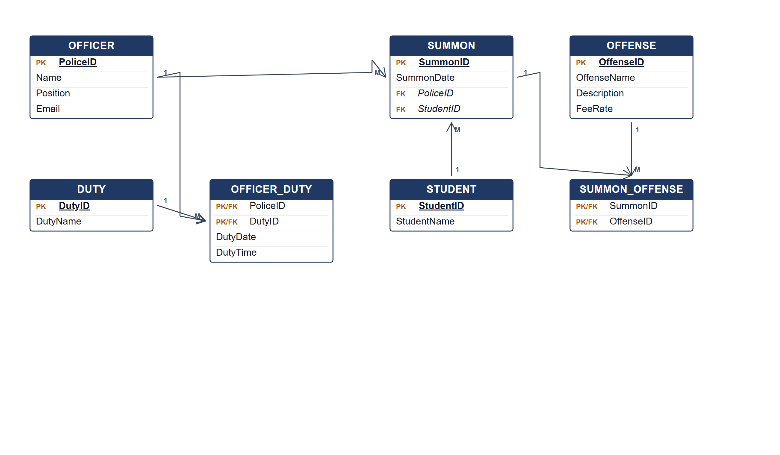
Auxiliary police ERD.
(b) Two pieces of information from the ERD. [4 marks]
• Which officers are assigned to each duty and when.
• Which offenses and fees are attached to each student summons.
Marking guide
• a) 16 marks: officer/duty/student (5); summon and offense (4); associative entities and relationships (5); keys (2).
• b) 2 marks for each information item (4).
Provenance: model_unofficial · confidence medium · Model-authored from the approved question text, the supplied source assets and the ICT200/ICT450 knowledge base; no official ICT450 marking scheme was supplied.
Knowledge base basis: TOPIC 4 ERD_stu (2).pdf; TOPIC 3 RELATIONAL DATA MODELstu.pdf
Assumptions / notes
• Each summon is issued by one officer to one student and contains one or more offenses; duty assignment carries the date and time.

